**Group 7 : REQ Project**

**a. Book publishing service** Expression is a book publishing company. Submitted manuscripts are evaluated and published on the expenses of the company or suggested for self-publication on the author’s expenses. The company manages proofreading, typesetting, printing, storage and shipping on its own. The books may be sold in digital or paper format. They also own a bookstore, but collaborating with reselling companies is the most common way the business is run.

**b. Food order & delivery service company** The value proposition of the Food-to-Table supplier is to enable selection, ordering and delivery of food to restaurants, companies, organizations and even end-customers, on a payment basis. The offer includes groceries, beverages, fruit and vegetables, meat and seafood, as well as ice creams and cakes. Food can be delivered on its optimal temperature, chilled, or even frozen.

(muokattu)

[

15.05

]

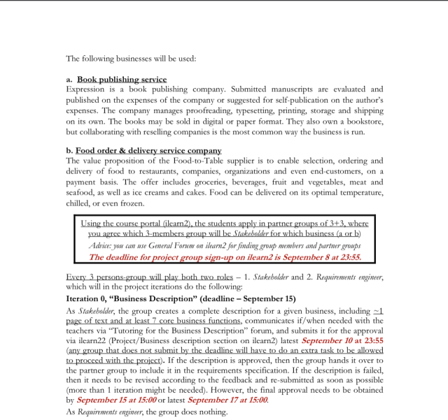

one page description through brainstorming the given business .. the page must also include at least 7 core business functions (derived from the description)

Subgroups

7a. Lovisa, Peilin, Nish

7b. Joseph, Usama, Shubra

Miro invitation link:

<https://miro.com/welcomeonboard/eWxsOUY5NUE0aW1ZVENnbHVJZGNSWmpIZGIxa3FqcUtqcE5MbHdiVVNlUzFMOHptc3V3bGxtZjZKZ0xjQm42cHwzMDc0NDU3MzYyOTUyMTg1MzYw>